Lab 1

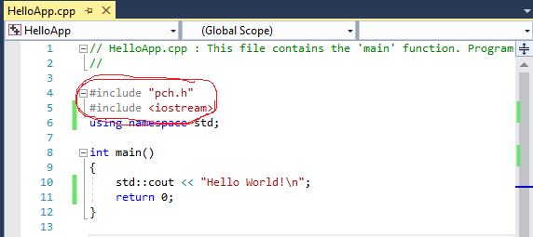

Figure 1

The #includes “pch.c” and #includes <iostream> are header files that need to be included for functionality. These give your program access to library’s.

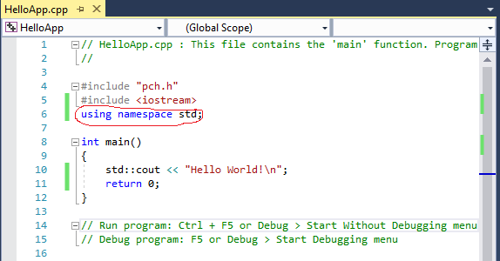

Figure 2

This line tells the program that we will be using std library. This will allow us not to have to load the whole library.

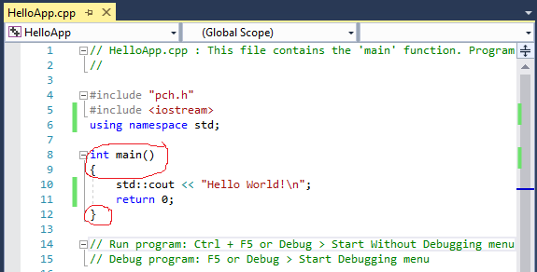

Figure 3

This is the main loop, we use int main() because the OS is expecting an integer back to end the program.

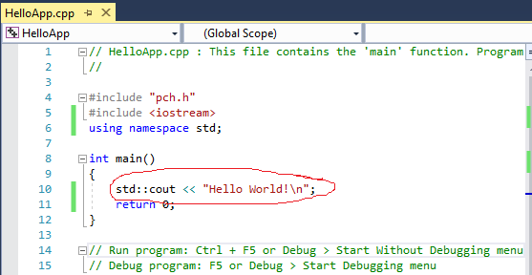

Figure 4

This is the where we are going to print “Hello World!” to the screen with a new line at the end. Std::cout is the standard library followed by the out put command.

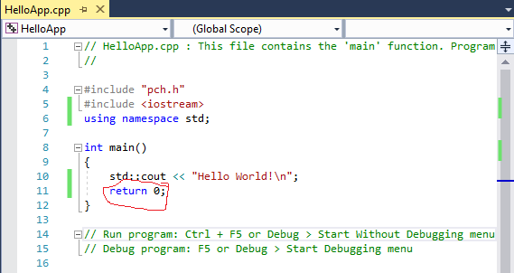

Figure 5

This will cause the program to return a 0 to the OS to end the program.